Task7:

Q: Given an integer array numbers move all 0's to the end of it while maintaining the relative order of the non-zero elements. Note that you must do this in-place without making a copy of the array.

**Analysis:**

* Assign variable nonZero values to track the position of non-zero values
* Swap the non-zero values with the position indicated by nonZero
* It’s moves non-zero values at the beginning of the array
* Replace the values at nonZero with zero
* Increment nonZero value to the next non-zero value.

**Flowchart:**

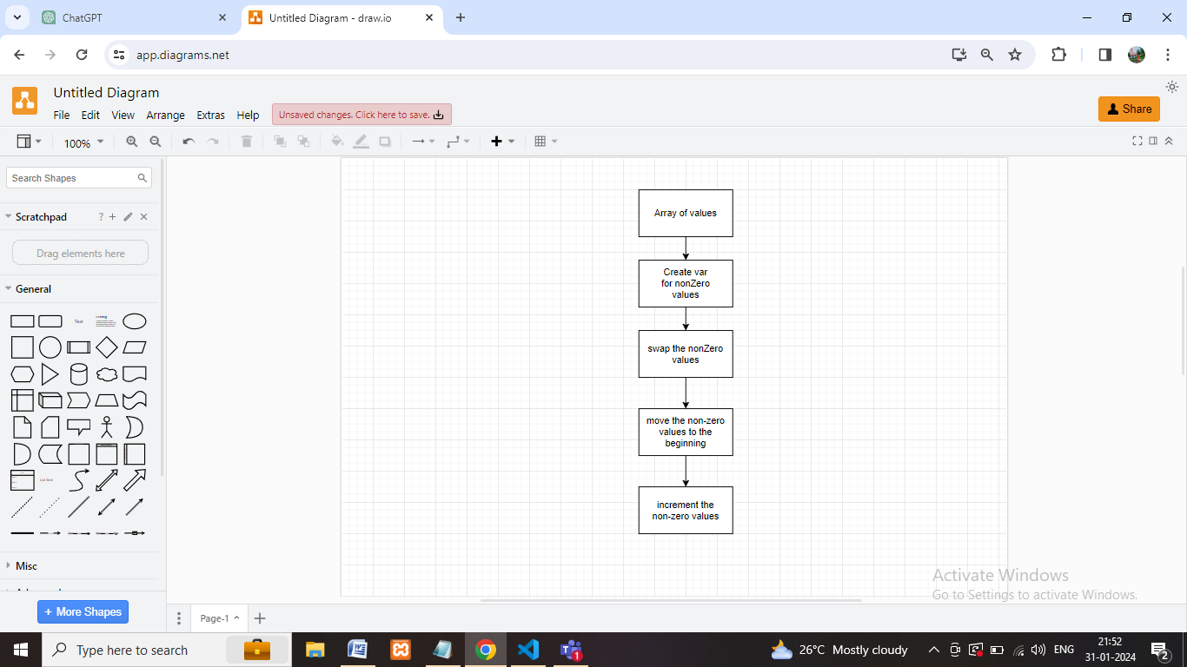**s**

**Coding:**

function task7(array)

{

    let nonZero = 0;

    for (let i = 0; i < array.length; i++)

    {

        if (array[i] !== 0)

        {

            let temp = array[nonZero];

            array[nonZero] = array[i];

            array[i] = temp;

            nonZero++;

        }

    }

    return array;

}

let array = [0, 1, 0, 4, 0, 3, 12];

console.log(task7(array));

**Output:**

